

**NEW WEEKLY JOB POSTINGS FROM   
HELP WANTED ONLINE  
Office of Research**

**Week Ending February 4th, 2023: New Ads fall 12% Over The Week**WETHERSFIELD, February 10th, 2023 – During the week ending February 4th, there were 6,662 new postings, down 942 new ads or -12% from a week ago. Most of this decline occurred in Manufacutring (-341 new ads), Professional, Scientific, & Technical Services (-93 new ads), and Retail trade (-88 new ads). The employers with the largest respective new ad declines in those three industries were Raytheon (-245 new ads), KPMG (-87 new ads), and Sherwin Williams   
(-21 new ads). Occupations with the largest decrease and increase over the week were Retail Salesperson (-67 new ads) and Supervisors of Food Prep & Service Workers (+63 new ads). Among the employers with the most ads, most were within Health Care & Social Assistance, which accounted for 11 of the 25 employers with the most ads. Yale-New Haven Health System (275 new ads), Community Health Center, Inc. (112 new ads), and Hartford Healthcare (89 new ads) had the most ads within that industry. During the past five weeks of 2023, total new ads in Connecticut have ranged between 5,991 and 7,604 new ads. This range is much narrower than the weeks ending in late 2022 as is shown in the graph below.  
  
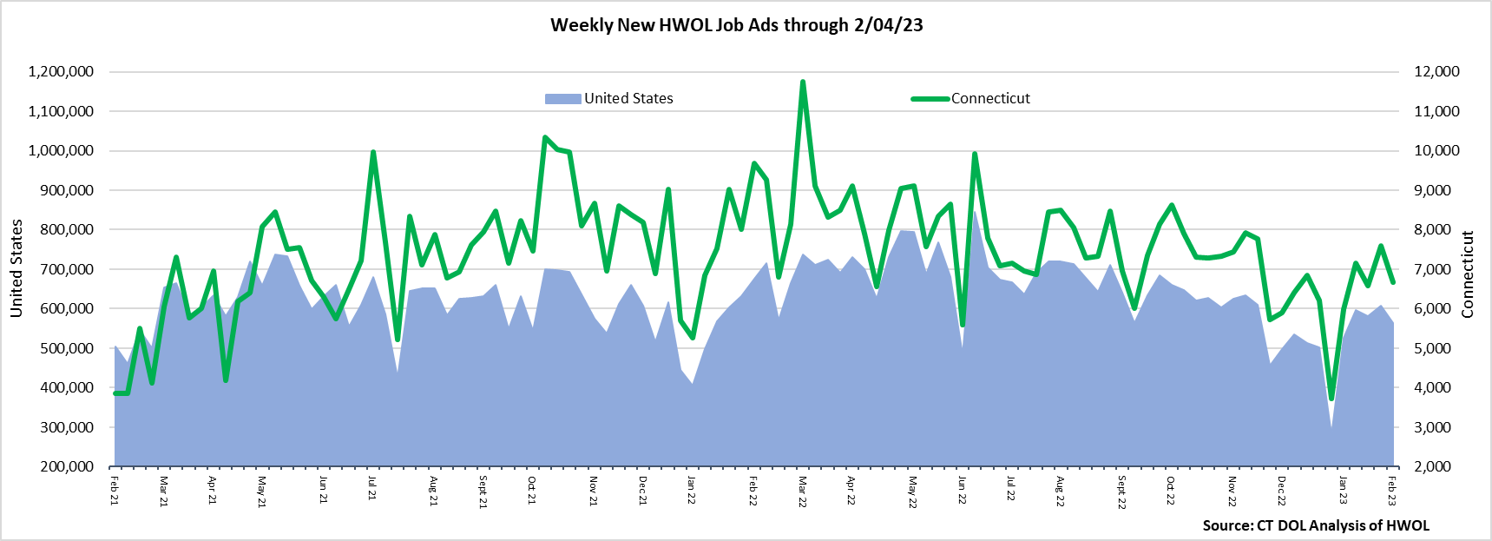  
**Industries** with the most new postings include Health Care & Social Assistance, Manufacturing, and Retail Trade.

**Occupations** with the most new postings include Registered Nurses, Retail Salespersons, and Wholesale & Manufacturing Sales Representatives.

**Employers** with the most new postings include Yale-New Haven Health System, Community Health Center Inc., and Hartford Healthcare.

**The three industries with the most new job postings were:**

* **Health Care & Social Assistance** (1,730 new postings, -2% over the week)
* **Manufacturing** (556 new postings, -38% over the week)
* **Retail Trade** (547 new postings, -14% over the week)

   
 During the week ending February 4th, 2023, the 942 new ad decrease is the net result of a combined 1,065 ad decline among fourteen industries and a combined 123 ad increase among five industries. Manufacturing had a 341 new ad decrease over the week, which follows a 337 new ad increase during the prior week. Most of this can be attributed to Raytheon which was down 245 new ads over the week after having increased by 234 ads in the prior week.  
During the week ending February 4th, the five increasing industries grew by 72 new ads or less. Accommodation & Food Services had the largest increase (+72 new ads) and the employer with the largest increase in that industry was Starbuck’s Coffee (+47 new ads).  
  
 For more information on total job ads by industry for Connecticut and its labor market areas, see the monthly report available here: <https://www1.ctdol.state.ct.us/lmi/hwol.asp>

**New Job Postings by Occupation** 

**The occupations with the most new postings were:**

* Registered Nurses (462 new postings, +5% over the week)
* Retail Salespersons (152 new postings, -31% over the week)
* Wholesale & Manuf. Sales Representatives (135 new postings, -6% over the week)

**Employers with the Most New Job Postings** Employers with the most new job postings during the week were mostly within Health Care & Social Assistance, Retail Trade, and Manufacturing. Healthcare & Social Assistance accounted for eleven of the top 25 employers. The 25 employers shown above combined account for 1,404 job ads or 20 percent of all new ads. Raytheon had the largest over the week decrease, down 245 ads over the week. This over the week drop at Raytheon follows a 234 ad increase during the week ending January 28th, 2023.   
  
**What is HWOL?**The **Conference Board Help Wanted Online**® Data Series (HWOL) measures the number of new, first-time Online job postings and jobs reposted from the previous month for over 16,000 Internet job boards, corporate boards, and smaller job sites that serve niche markets and smaller geographic areas. To view more HWOL data, go to: <https://www1.ctdol.state.ct.us/lmi/hwol.asp>